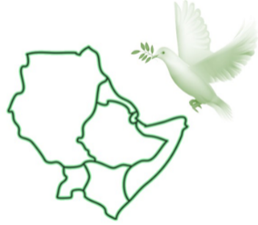
AEDHCA
ACTING TOGETHER FOR HUMAN RIGHTS IN HORN OF AFRICA
agirdroitshumains-corneafrique@gmail.com
Frankfurt, December 27, 2021
Press release
ACTING TOGETHER FOR HUMAN RIGHTS IN HORN OF AFRICA -AEDHCA- denounces the extra-judicial executions of 2 Afar citizens of Djibouti by the Djibouti security forces on December 15, 2021 near Buldhuqo (suburb of the capital), buried hastily by security officers on December 17th.
AEDHCA also denounces the death under torture of the Police and Security of the young man, Farah Louback on December 18 in Gabode prison in Djibouti. He was among around 30 people arrested following peaceful protests in several towns to celebrate the Afar region’s victories against Tigrayan attacks in Ethiopia. Several of them are subjected to torture in the premises of SDS (Documentation and Security Service).
ACTING TOGETHER FOR HUMAN RIGHTS denounces the Afar hunt which has been going on with impunity for 3 months by the Police assisted by elements of the Army in the districts of Tadjourah, Dikhil and Obock.
Arbitrary and illegal arrests number in the hundreds, to this day around 100 people remain in detention in Gabode prison and police centers, where they are subjected to torture and degrading and inhuman treatment. Police officers under the orders of Colonel Abdillahi Abdi carry out unprecedented violence against women, and commit crimes of rape. In the North and South-West of the country.
This harassment and violence forced herders and their families (500 families) to flee the regions of Syarou and Gagadé and take refuge in Ely Daar in Ethiopia.
AEDHCA: Calls on all democrats as well as international institutions committed to respect for human rights to denounce the extrajudicial executions of Afar citizens, arbitrary arrests and torture, as well as the rapes of Afar women and to support families tried and misplaced.

Idris Adam, idrisadam1812@gmail.com

